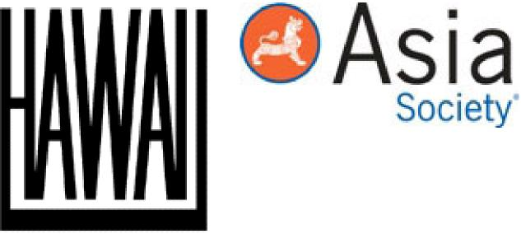
Significant Patterns on Chinese Bronze Mirrors
Author(s): Schuyler Cammann
Reviewed work(s):
Source: Archives of the Chinese Art Society of America, Vol. 9 (1955), pp. 43-62 Published by: University of Hawai'i Press for the Asia Society
Stable URL: http://www.jstor.org/stable/20066972
Accessed: 30/04/2012 08:34
Your use of the JSTOR archive indicates your acceptance of the Terms & Conditions of Use, available at http://www.jstor.org/page/info/about/policies/terms.jsp
JSTOR is a not-for-profit service that helps scholars, researchers, and students discover, use, and build upon a wide range of content in a trusted digital archive. We use information technology and tools to increase productivity and facilitate new forms of scholarship. For more information about JSTOR, please contact support@jstor.org.
 | University of Hawai'i Press and Asia Society are collaborating with JSTOR to digitize, preserve and extend access to Archives of the Chinese Art Society of America.

Significant Patterns on Chinese Bronze Mirrors'
Schuyler Cammann
University of Pennsylvania, Philadelphia
T
HE skilfully composed patterns of animals, birds, legendary gods, and antique symbols, on the backs of the Chinese bronze mirrors, which are now so well represented in our leading collections of Oriental art, immediately impress us by their aesthetic
beauty. But pleasing aesthetic effects were only incidental for the makers and users of these mirrors, a mere by-product of their manufacture. The traditional-minded Chinese of the past considered this beauty the inevitable result of expert craftsmanship, which was automatically expected of both the designer and the artisan who carried out his design.' For the old Chinese, the important consideration was the significance of the pattern on the mirror back, and the deftness or subtlety with which its message was expressed was what made it an effective design.

It must be emphasized that the Chinese bronze mirrors of the great period—from the Late Chou through the Tang Dynasty (c. 550 B.C.- 900 A.D.) —were rarely ever mere looking-glasses, in the sense conveyed by our use of the word mirror. Of course some of them were used for vanity's sake, but the primary purposes were for ritual and magic, and the decoration on most mirrors had symbolic meanings referring to these basic uses.'
Although the interpretation of any of these patterns must have been more or less obvious to the artisans and their patrons at the time when a given style was in use, it usually takes more than a casual glance to decipher them today. In fact, the effort to read their meanings is useless unless it is done with scientific methods, by referring to the history, related arts, and literature of the period when each basic type of mirror was made, to determine as accurately as possible the thought trends of the time.'
The patterns on the earliest Chinese mirrors, from the Later Chou, the period of the Warring States, and the short-lived Chin Dynasty (6th through the 3rd centuries B.C.) , are the most puzzling of all.' They often appear to be merely pleasing abstractions. However, they were made at a time of troubles—an era of civil war and political and economic chaos, caused by the gradual collapse of the old feudal system and subsequent ruthless attempts to impose unity on the divided nation—and the constant atmosphere of terror led people to put great reliance on ritual and magic in the effort to ward off disaster. Therefore, it seems probable that many —if not most—of these mirrors were made for ritual use, and that they contain correspondingly appropriate meanings in their abstract-looking patterns.' Unfortunately, we can only hazard a few guesses about possible meanings for some of the simpler ones; for, with the wholesale burning of the books under the First Emperor in 213 B.C., and the total destruction of his capital a few years later, practically all records of China's earlier rituals and their symbols were permanently lost, in spite of sporadic efforts to reconstruct them in later times.'
The simplest and most basic patterns, constantly recurring on these early mirrors, consisted of a broad band incised within the outer rim, and a second band circling the boss at the center, with a relatively simple design filling the space between them. The filling design generally consists of tightly packed scrollwork suggesting writhing clouds, over which is sometimes imposed a linear pattern made up of interlaced

dragons, as on the example in Fig. 1.⁸ The area within the inner circle, immediately around the boss, is usually left bare of decoration, although sometimes the cloudlike background drifts on across it,' and in later examples it usually frames, or contains, a celestial dragon whose head forms a loop-boss." The pattern of a disc with an "open" center immediately recalls the perforated jade disc (yu pia) often ornamented with small, tight cloud-scrolls, which was the ancient Chinese emblem of the Sky.
The presence of the hole in the jade sky-discs has baffled many later antiquarians seeking to explain or interpret the ancient Chinese symbolism. However, it can easily be accounted for by referring to ancient concepts about the nature and formation of the sky—which, incidentally, were apparently not confined to China.'
The ancient Chinese thought that the earth was a flat—or slightly curved—square surface, surmounted by a circular sky. According to one traditional explanation the sky was a flat disc upheld on mountain-pillars, while another considered it as an inverted bowl fitting down over the earth.' In either case, the sky was thought to have a hole at its center, in the North where the stars appear to revolve around a stationary Pole-star. The Chinese called this the Chang-hob or Heavenly Gate, and through it the Lord of Heaven was believed to observe what went on among men, while the prayers and sacrifices of mankind could ascend by it to Him." Thus, the circular pattern with a quasi-perforation in the center could have transformed the mirror into a symbol of the all-powerful Sky, just as some later mirrors were made into more obvious sky-symbols by patterns of dragons among clouds."
At the height of the Former Han Dynasty, during the reign of Emperor Wu (140-87 B.C.) , a new culture began to emerge and new ideas asserted themselves. The mirrors themselves suddenly underwent a marked change, becoming much larger and heavier with a greatly emphasized boss to replace the delicate triple loop of the earlier ones. (This development is shown in
Figs. 2 and 3.) The new high boss in itself was an expression of new concepts which involved a belief in the magical powers concentrated at a hypothetical "center of the Universe" at the base of the Earth-Sky axis.
This was apparently due to Emperor Wu's revival of interest in the idea of a cosmic house called the Ming Tang,c in 110 B.C., following a tradition that such a building had been used in the Chou Dynasty by the Supreme Ruler for ritual magic." Built at the assumed base of the World-axis, it was expected to assure magical powers over the forces of the Universe to the sovereign who officiated there. This was not the only reason for contemporary interest in the idea of a cosmic center—we shall consider some of the other reasons later—but it apparently had a great deal to do with the pattern on one of the most common forms of Han mirror design, the so-called "TLV" pattern, an example of which is shown in Fig. 3.
The "TLV" pattern seems to have had its tentative beginnings on a late form of the earlier thin metal mirrors in the first century of Han rule, reaching its full development in the reign of Emperor Wu, about 100 B.C.;" but the most highly elaborated examples appear to have been cast in the early part of the first century A.D. The mirror shown in Fig. 3 must date from that period, as it was found in a Han tomb in Kansu, together with coins issued by the first Emperor of the Later Han Dynasty, who reigned from 25 to 58 A.D.
The odd-looking grooved marks, on this type of mirror, which have suggested to Occidental viewers the letters T, L, and V—hence the popular Western name for the type—have been completely ignored by Chinese scholars and connoisseurs for many centuries. Since the Sung Dynasty, they have consistently overlooked these marks, apparently not recognizing that they were characteristic of a definite group of mirrors, and have simply classified the mirrors that had them by other elements in their design or by key-words in their inscriptions; thus placing them in several, apparently unrelated categories.'

However, the men of Han were not inclined to insert such prominent features as these merely for "pure ornament" or as fanciful decoration, and by studying some of their beliefs, the writer has recently discovered how these marks were deliberately placed to bring out the basic meaning of the whole design."
Notice that the V's opposite the corners of the inner square mark off what would be four outer squares if the latter were not partially covered by the broad circular rim that has been superimposed on the basic pattern. Therefore, the essential plan of the portion within (or below) the rim consists of a large square, around the central boss, set within a cross. Each of the four arms of the cross bears one of the Four Spirits, semi-sacred creatures which the Chinese had selected to designate the four cardinal points. These were the Black Tortoise (and snake) of the North, the Azure Dragon of the East, the Red Bird of the South and the White Tiger of the West." They were placed thus on this particular pattern (sometimes silvered for greater emphasis, as in Fig. 3) because, to the ancient Chinese, a square within a cross, the arms of which were formed by four other squares, was the traditional way of representing the world with its five directions (North, South, East, West, and Center, collectively known as the "five squares," wu fang,d) and the presence of the four creatures to label the cardinal directions stressed this all the more forcibly.
Meanwhile, the broad rim, figured as an open disk with a continuous band of conventionalized clouds or vapors, could only have represented the sky, which in Han cosmology was generally believed to overlie the world, resting within its corners. In short, this was the old emblem of the sky, like the jade Pi, although the width of the central aperture had been greatly increased to give a wider view of the Earth beneath it.
The middle of the world for the Chinese was always their own country, the "Middle Nation."" Hence, the central square on the Han mirrors, on some of the Han sundials, and on contemporary game boards—all of which were constructed on essentially the same cosmic pattern"—represented China itself. The wide border which sets off the central square on the more elaborate of these mirrors is often marked off by small bosses into little compartments, in each of which is inscribed one of the twelve characters which represent the "houses" of the Far Eastern zodiac, marking the successive progress of the celestial bodies. They were also used to designate the double-hours of the day, successive days in a month (by repeating) , and the twelve months of the year, as well as cycles of years in the sixty-year units. Their presence here suggests the conviction that China was the source of balance and order, as well as being the center of civilization and of the very world. At the exact center of this inner square was the high round boss, with its four projecting points which may have represented radiating powers or good influences. This boss probably depicted the Ming Tang with its rounded roof, erected at the cosmic center of China, and hence the world; it certainly marked the central axis of the universe.
The four T-shaped projections from the sides of the inner square must have represented gates. This we can tell partly from the numerous references in earlier Chinese literature to the (figurative) Four Gates of the "Middle Nation" (China) ,²² and partly from the treatment of the similarly-placed T-forms on the later Tibetan mandala paintings, whose basic plan seems to have been derived from these mirror patterns—or at least from the same prototype—as can be seen from the example in Fig. 4." The mandala diagrams almost always show the T's surmounted by actual gate towers, as they are here.
According to various passages in Chinese literature, the Four Gates opened out into the four regions of the "barbarians," which were usually referred to poetically as the "Four Seas."' Hence, along with the creatures of the four directions, the outer squares on the more developed examples of the "TLV" mirrors often contained wild animals and birds, and even savage men (or spirits) , occupying the spaces beyond

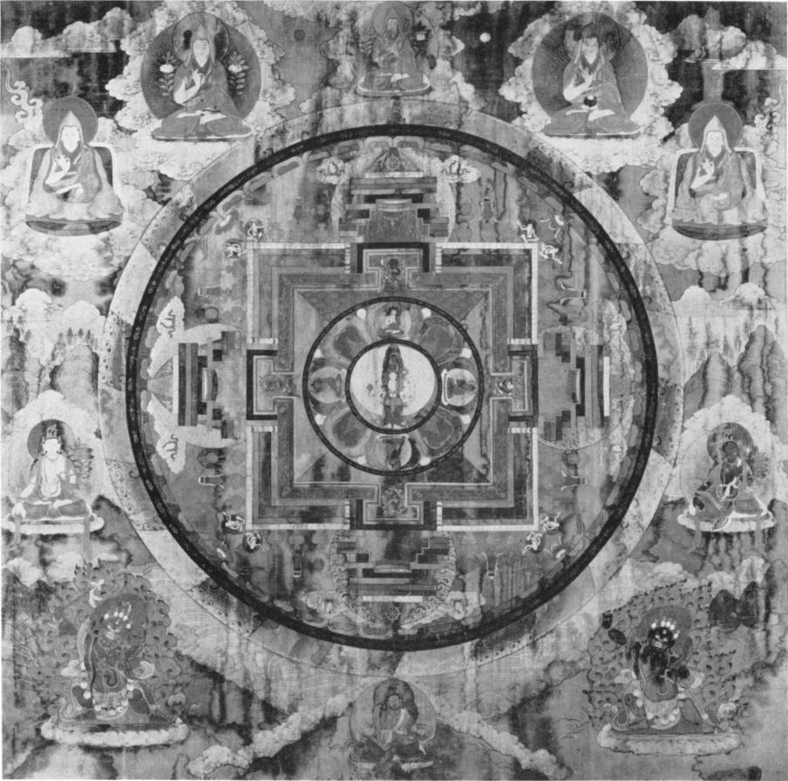
Fig. 4. Lama mandala painting.
Royal Ontario Museum of Archaeology, Toronto.

the T's. Another later diagram from Tibet, a Lama yantra in the Newark Museum, which also has a basic structure clearly derived from the "TLV" pattern, renders the concept of the "Four Seas" extremely literally, by representing beyond the T-shaped gates, on the four sides, actual water, in which sea monsters, bearing the colors appropriate to the four directions, disport themselves among the waves."
The exact meaning of the L's is somewhat more difficult to determine exactly, because they seem to have had two possible origins- although these are not irreconcilable. It would seem most logical that they must have represented gates to the outermost parts of the universe, through which the winds and rains entered from the outlying regions of the dank swamps which are sometimes mentioned in Chinese cosmological writings." The theory that they were actually intended to be gates would seem to be supported by the fact that, on at least one mirror of this period, the usual T's of the inner square were replaced by L's, indicating that these two sets of marks could be interchanged."

On the other hand, we have evidence of another sort from a contemporary cosmic game called /in-po.e The liu-po board carried essentially the same basic pattern as these mirrors, having the square within the cross, and the T's and L's in the same places (except that it lacked the outer ring, and the center was not stressed until the winner placed his leading counter there) ;²⁵ and one account of this game refers to the L's on the board as "caves.^{,)29}
Conceivably the two sets of ideas might be reconciled by some concept of access to the outlying regions of the world through cavelike entrances, or even tunnels. In any case, the region behind the L's must undoubtedly have been considered as wet, because one TLV mirror depicts fish lurking behind these angles in the east and west squares." The east and west sides of the mirror, by the way, also stood for Spring and Autumn, since the Four Spirits (the directional animals) also stood for the Four Seasons. In fact, the bent L's, all turning in the same direction, give the whole pattern a rotational quality that suggests the revolving seasons of the year, with the waxing and waning of the forces of the yin and yang.
Anyhow, what the L's specifically meant is probably less important than the meaning of the other elements in the pattern, because they were obviously the least significant features. Some examples showed the central square with the T's alone, while others showed it with only the V's;" but apparently none ever had the outer L's alone, so they were obviously least necessary for carrying out the symbolism. These variant combinations indicate, moreover, that the basic pattern consisted of the outer circle and inner square—usually, but not always, standing within a cross marked off by the V's—and was completed by the highly emphasized boss at the center.
One closely related variety of Han mirror, illustrated in Fig. 2, is even more greatly simplified. The pattern consists merely of the large boss with its four projections as the conventional representation of the axis of the earth (or, more specifically, the Ming Tang) , as seen through a representation of a jade pi as emblem of Heaven. This was certainly the most simple way of representing the universe as the union of Heaven and Earth, without the need of T's, L's, V's, directional animals, or any of the other traditional appurtenances of the more elaborated cosmic mirrors of that time.
Functionally, it was quite unnecessary for the Han mirror bosses to be so grotesquely large. In fact, from a practical point of view, their size was a disadvantage, as it added considerably to the total weight of already-heavy mirrors. The only apparent purpose of an exaggerated boss, then, was a symbolic one, to emphasize the center of the mirror and to make it the dominating element of the universe pattern as a whole. This conforms precisely with the contemporary philosophies which were greatly preoccupied with the concept of the Center of the World, the Universal Axis, the motionless turning point around which the Universe revolved—the Point of Origin.
The great majority of Chinese symbols had more than one significance, on different levels of thought, and the concept of the center was no exception to this. Taoist beliefs, which were particularly strong in Han times, stressed the mystical ideal of seeking union with the Origin, the Noumenal, the One, at the center of all things.
The more superstitious men of the time thought that this could best be accomplished by conducting magical rites with the aid of universe diagrams, if not in an actual Ming Tang, and that it would result in the procuring of material powers. Thus, Wang Mang, who reigned as Emperor during the interregnum of 9-27 A.D., when he knew that an avenging army was closing in upon him, tried to "attain the Center" in order to save himself. (The method did not work, and he was brutally murdered.) ³²
The higher thinkers of the period, by contrast, apparently believed that if a person could establish control over his own Self, by keeping the contrasting elements of yin and yang as they occurred in his own personal world neatly bal-

anced around a central point, he would then not only be truly the well-composed master of his own situations, but could also obtain magic power from the higher Tao."
To either end, the patterns on these Han cosmic mirrors with their prominent and often highly polished boss, were eminently suited; either for self-hypnosis, or for more-balanced meditations on the nature of the universe and especially upon the inner meanings of its vital center.
The Han Dynasty began to show signs of breaking up in the second century A.D. and when it finally disintegrated, China was divided for three hundred and sixty-eight years, during the Three Kingdoms and Six Dynasties periods (A.D. 221-588) . Throughout these dark centuries of recurrent civil wars, foreign invasions, and general anarchy, Buddhism exerted a strong appeal, although it was a foreign religion and had only been recently introduced to China. Under its influence, or goaded by the competition, Taoism became an organized religion with its own scriptures and pantheon, instead of a series of philosophic beliefs. The Taoists of that time strongly emphasized the cult of the goddess Hsi-wang-mu,' and her consort Tung-wangkung,g which accounts for their presence on many mirrors of this period." Fig. 5 shows a typical example from the Late Han or Three Kingdoms period."
The goddess and her consort are always rigidly conventionalized. On the earlier mirrors of this period, they are usually represented by mere flat drawings with the outlines in low relief, and their figures are generally clearly labelled by the inclusion of Chinese characters, as illustrated in Fig. 5. Later, during the Six Dynasties, they were placed on another kind of mirror with their bodies in high relief, as shown in Fig. 6. They are no longer identified by characters, but rather by their crowns. Hers has three softly rounded projections, while his has three more aggressive-looking spikes, thus recalling the yin and the yang of which the divine couple were considered as personifications.
In either case, they are definitely subordinate to the huge boss, which is fully as large in diameter as those on the mid-Han mirrors but a trifle less jutting, being characteristically somewhat flatter. By now, the meaning of the boss seems to have altered. The prominent boss of the earlier cosmic mirrors probably represented the Ming Tang, as suggested above. In fact, inscriptions on some of them dating from the first century A.D. specifically refer to the building of a Ming Tang," which virtually informs us that this must be depicted or symbolized somewhere in the pattern, and, in view of the centrist philosophy with which it was associated, it would have to have been placed in the middle of the Universal plan. At this later time, however, the mirror boss must have been considered as representing the World-mountain, Ktun-lun Shan,' the Chinese equivalent of the Hindu-Buddhist Mt. Meru, "at the center of the world."" Because, not only did the boss occupy the center of this later type of cosmic pattern, but the patterns portrayed Hsi-wang-mu on the left of the boss, and Tung-wang-kung on its right; while an almost contemporary text describing Kunlun Shan explicitly states that Hsi-wang-mu ruled west of the peaks (her name means "the Western Mother-queen") , while Tung-wangkung ("the Eastern Father-king") ruled to the east of them." Therefore, the boss that reared up between them on the mirrors must have stood for the mountain in question.
Since this group of mirrors obviously placed such strong emphasis upon the central mountain of the universe—which at this time was considered as the abode of the Immortals, as well as the axis of the world—their patterns seem to have been primarily intended to suggest the blissful life after death at the center of the universe, for use in burial rites. That would help to account for the great numbers of them that have been recovered in recent years from Chinese tombs of that period. In that troubled age, the hope of a happy and contented life after death, to compensate for their earthly travails, was no doubt much in peoples' minds. To support this

hypothesis, the patterns often show subordinate figures of highly conventionalized Immortals, paying court to the divine rulers, or enjoying themselves in dances, chariot driving, or even in playing /iu-po." Sometimes an Immortal is depicted riding a fleet horse to escape from a raging monster, who may have represented total death and annihilation.
However, another concept is very strongly emphasized on these Hsi-wang-mu and Tungwang-kung mirrors. That is the Taoist idea of the two great natural forces in the universe, the yang and the yin, as contrasting representatives of male and female, spiritual and material, light and darkness, Heaven and Earth, etc., interacting in perfect harmony to make the universe basically a unity formed of individual dualities. This concept is already suggested on these mirrors by the contrasted figures of the Eastern King-father and the Western Queen-mother, wearing their differing crowns. But the opposition is often further stressed by presenting on the other two sides (top and bottom) the Azure Dragon and the White Tiger, as representatives of the yang and yin, as well as opponents signifying East and West, Spring and Autumn, aggressive power versus passive strength, etc. (They are shown in Fig. _{5.)} 40
These mirror patterns which so graphically portray the old Chinese concepts of two contrasted sets of forces working together in the unity of a single universe, might have been intended merely to illustrate a fundamental point in Taoist doctrines; but it is also possible that their symbolism was intended to be interpreted in another way, and that some of these at least may have been intended to serve as "marriage mirrors," a category which was highly developed later on, as we shall see, particularly during the Tang dynasty. Yetts believes that the suggestion of fertility was also implicit in the portrayal of this royal couple," and if so, that would establish another link with the later marriage mirrors, on which this concept was often emphasized.
The final century of the Six Dynasties period was marked by an intensified struggle for power between the various states into which China had been divided, until the entire nation was once again brought together under one ruler in 589. The Sui dynasty which accomplished this unification did not last very long, but it set the stage for China's second great empire under the Tang dynasty (618-907) . The mirrors of the Sui and Early Tang express the sense of unity regained and a new integration by a variety of significant patterns. Most of these were based on the same general design as the old Han "TLV" pattern, with some slight variations. The T's and L's had meanwhile dropped out, but we still find the inner square setting off a prominent boss, within a cross marked off by the V's, with the whole design enclosed within a broad, circular rim. Two examples are shown in Figs. 7 and 8.
This basic pattern was more than a mere survival, or revival, of a once-popular pattern; it marked the reassertion of old beliefs regarding the nature of the Universe, and the changes indicated modifications in ideas with the passing of several centuries. The V's remained because they were needed to set the limits of the four outer squares, which still symbolized the four directions—labelled as such by the presence of the directional animals. However, the T's and L's are no longer there, because the gates of the world were now thought to be located at the outer edge of each square, so that they would fall beyond the rim of the sky, as represented by the wide circular ring around the outside. Also, the "Four Seas" were now, more literally, considered as bodies of water lying beyond and between the four squares, and each was thought to be guarded by a dragon-monster—hence the small monster heads so often shown within the V's on these patterns, as shown in Fig. 8.
Another characteristic feature which these Sui and Early Tang cosmic mirrors had inherited from their Han prototypes was the presence of the quatrefoil design projecting outward from the boss. (When a fifth directional animal was shown, under the boss as in Figs. 7 and 8, there

was of course no room for this, so it was omitted.) This motif has persisted through the centuries in Central and Western Asia as a conventional sign to indicate the base—or summit —of the world axis, whether the axis is actually represented or merely understood to be present." (Here, the boss undoubtedly still stood for the central mountain which served as the axis of the world.) As late as the 18th century this cruciform symbol with open center, popularly known as a "cloud collar" (yiin chieni) in later Chinese terminology, was figured atop the dome of a Manchu Emperor's tent for Court audiences; and the tent itself was clearly intended to portray the Universe in microcosm, just as these mirror patterns were, since it had a cross-shaped throne dais to symbolize dominion over the four directions under a bowl-shaped covering to represent the enclosing sky.'
As previously mentioned, the arms of the cross on the Sui and Early Tang mirrors were usually figured with directional symbols. The Four Spirits of the Han mirrors reappear, but now they are much larger, frequently filling the whole space within each cross-arm. On a number of examples, these animals have been inverted. That is, on turning the mirror clockwise, they read south, east, north, west—instead of north, east, south, and west—and north and south can only resume their proper positions when the mirrors are held upside down, overhead. This placement was evidently not the result of an accident or mistake—in carving the design in reverse for the original mold, for example—because so many incidences of it would indicate a deliberate intention.
The basic reason for this inversion of the animals seems to have been that a readjustment of the pattern was required because at that time mirrors were hung from the ceilings of tombs, temples, and shrines, to symbolize the metaphysical Sun- or Sky-gate at the apex of the dome of the sky." If the mirror so used had been hung reflecting-side down, the pattern would remain the same; but if it were hung pattern-side down, for metaphysical reasons—or if it were placed on an altar or coffin with the reflecting side up, to catch the light from another in the ceiling, in order to establish the lower end of an axis of light—the directional symbols on the pattern would have to be readjusted, as they were in the examples mentioned above, in order to fit the new orientation. The same phenomenon is seen on one of the two principal types of Tibetan mandala paintings, which were originally derived from universe-diagrams painted on the ceilings of Lama shrines. On these, too, the directions are inverted until one holds the painting overhead, when they assume their regular order facing the proper directions.'
On some of the Sui-rang cosmic mirrors, the Four Spirits are replaced by figures of lions, while occasionally a fifth lion is shown emerging from under the boss. (See Fig. 8.) The fact that these two sets of symbols were interchangeable would imply that they had similar functions, and that therefore the lions were also considered as directional symbols. Indeed, it seems certain that they were intended to represent the Lions of the Five Directions, who figured in a contemporary dance by that name, recently introduced into China from Central Asia, which was performed to the accompaniment of the "Music of Universal Peace."" Thus, the mirror patterns which showed the lions displayed on the universe diagrams were graphic representations of an ordered universe at peace, neatly expressing the intense gratification of the Chinese at their reunification and the re-establishment of order in the land.
As long as it was considered necessary to represent the World-mountain at the center of the earth by a prominent mirror boss, there was not much room for the fifth lion. But, since the fifth lion represented the Center, considered as the fifth direction of space—even on Four Spirits mirrors with the other set of animals, as shown in Fig. 7—the next group of mirrors solved the problem by simply using the arched figure of the central lion to form the boss. Some of the latest mirrors of the former type carry inscriptions with a date equivalent to 650 A.D.' and this

new type, characterized by five lions with one serving as the boss, against a background of grapevines, as shown in Fig. 9, appears to have come into fashion shortly after that date.⁴⁸
The grapes, as symbols of abundance in a world at peace, would have had especial significance for the Chinese Court at that time, because in the year 640, the art of fermenting grapes to make wine was introduced to rang China from a state in Eastern Turkistan.⁴⁹ Also, to symbolize another form of joy appropriate to a world at peace, namely that which comes from fine music, sweet-singing orioles commonly figured on the earliest example of lion and grapes mirrors." However, both the grapes and the orioles, together with the lions, were appropriate symbols to illustrate some of the principal beliefs of the Manichaean religion, which was introduced into China at that time, so the mirrors may have had a double meaning. The fact that they were probably associated with Manichaeism is suggested by the sudden disappearance of this pattern after the middle of the 9th century when that religion was drastically persecuted. The pattern disappeared so completely that Sung dynasty antiquarians, scarcely two centuries later, no longer recognized them, and called them "Sea horse and grape mirrors" (hai-ma pru-teao chingi) after a pair of horses which were included with the lions on some examples in the Sung Imperial Collection.'
Before they went out of favor, the lion and grape mirrors went through a considerable evolution in pattern. The number of lions was gradually increased to represent other combinations of directions, planets, and elements, since the Five Lions—like the Four Spirits together with the Yellow Dragon (or a fifth lion) to symbolize the Center—were considered as symbols of the Five Elements and the Five Planets, as well as the Five Directions. Thus, we eventually find six, seven, eight, or nine lions in the central field of the later examples, standing for the six, seven, eight, or nine directions, or elements, of different philosophic systems.' In a ring circling this central field, where originally there had been only orioles, other forms of auspicious birds and animals were introduced; and we often find here the Twelve Animals of the Zodiac, which by this time generally replaced the twelve characters that also symbolized the zodiac, as shown in Fig. 10. Around this outer zone of birds or animals, was a bordering ring, usually figured with conventionalized clouds, to represent the rim of the dome of heaven. For these, too, were cosmic mirrors, even if their more freely-rendered patterns seem far removed from the formalized cosmic diagrams on the Han ones.
On some of the latest lion and grape mirrors, pairs of auspicious birds or animals, such as phoenixes, dragons, or spirit horses, appear in the central field among the lions, confronting each other from opposite sides of the boss; the animals in the outer ring were shown in pairs (together, or on opposite sides) ;⁵³ and even the lions in the central section were shown in pairs, sometimes with cubs.' These variations brought the mirrors which had them into the "marriage mirror" category.
By the middle of the Tang Dynasty, if not long before, it had become the custom for the bride to carry in her lap a bronze mirror for averting evil influences as she rode in a sedan chair to the ceremony, which was usually held in the home of the groom. After the wedding, this mirror would be hung over the new couple's marriage bed to ward off evil spirits and to insure happiness"—which included, of course, an abundance of children. Many mirror patterns of the Tang period bear symbols which clearly indicate such associations, showing that they must have been expressly intended for this usage.
The most obvious examples had pairs of auspicious birds, often carrying ribbons or cords to suggest the marriage bonds. Several species are commonly shown: notably the Chinese phoenix, or feng-huang, highly regarded for its inner qualities as well as its splendid appearance; peacocks, famed for their beauty; or geese or mandarin ducks, both of which enjoyed high reputations for their constancy and affection to their mates. Also included among the lucky

birds were magpies. They do not have in China the bad associations that they have had in Europe; in fact, during the Tang they became known as "birds of happiness" (hsi ch'iaok)," and, since the usual expression for happy marriage is "double happiness" (shuang hsi'), a pair of magpies produced a picture pun or rebus on this phrase, making them especially appropriate on the decoration of marriage mirrors, like the one in Fig. 11.
The pattern on this particular mirror carries out still further the symbolism of husband and wife, by including the moon disc, one of the chief yin symbols, and the soaring dragon which symbolizes yang. Thus, to the more reflective people of that time, the symbolism on this mirror would not only have conveyed the idea of lasting happiness in an ideal marriage, but it would also have suggested the enduring balance in the macrocosm—the harmonious interaction of the yin and the yang in the procession of the seasons, and in all other manifestations of order and balance in nature.
Less obviously symbol-laden at first glance, but in fact even more so, is the mirror in Fig. 12, which belongs to the University Museum in Philadelphia. The main pattern around the boss has, on opposite sides, the male and female of a lionlike monster known as suan-i,m the male one being identified by the horn on his brow. Below them are depicted parrot mates, eating grapes together to symbolize shared joys. Meanwhile the lobes of the rim contain opposed sparrows and opposed butterflies—also to be considered as contrasted mates in the realm of nature—along with twin buds, flowers-to-be, which would grow to fulfillment together.
These are all natural symbols of a human couple in the balanced harmony of happy marriage. Only the single crane, shown at the top, would seem to be an exception; but he, too, has his place in the total symbolism. The crane, besides being a common symbol of longevity in China, was considered to be a divine messenger, who transported the souls of the more-favored departed to the Isles of the Immortals in the
Eastern Sea, where they would enjoy eternal bliss.' Thus, the crane shown here in this context would convey the hope that the couple for whom this mirror was intended might live to a ripe old age together, and that, when the time came to leave this life, they might go forth together into immortality, on the back of the same crane.
Probably the most magnificent marriage mirror pattern ever devised, from the point of view of rich and meaningful symbolism, is shown on a rare Tang mirror in the Seattle Art Museum which is shown in Fig. 13.⁵⁸ This pattern has at its center a cross-shaped plan of the earth, radiating from a central axis-mountain which forms the boss, surrounded by the "Four Seas," very literally rendered with miniature waves, while the cloud wisps circling around it symbolize the all-encompassing sky. The two dragons within this central area are of course yang, or male, symbols; and the two tortoises are equally traditional yin, or female, symbols. A line drawn through the two dragons would form a positive, yang axis across the world here represented, while a line drawn through the tortoises would form a negative, yin axis. These two axes would divide the pictured universe between them, and yet would also share it.
The pictures on the middle band of decoration all show auspicious manifestations, from the beliefs of the Han Dynasty, or even earlier," introduced here in a new usage, as symbols of unity in duality. Turning the mirror clockwise, beginning with the sun and moon in conjunction, at the top, one sees two trees growing together, two fish with mutual eyes (one pair for both) , one melon springing from two joined stalks, two stalks of wheat joined to produce a single head of grain, two golden jewels linked by a single rod, two interlaced bamboos, two birds with mutual wings (only two for both) , two lotuses joined to make a single flower, two rice-plants joined to produce a single head, and lastly a pair of phoenixes, which were always considered the marriage symbol par excellence. To make the symbolism even more graphic, each

of these symbols is related to the one exactly opposite, making six opposed pairs of related symbols. Even the Twelve Animals of the Zodiac, which share the outer rim with the inscription, are shown marching in pairs, male with female, to carry out the total symbolism.
Altogether, this Tang mirror would seem to present an unusually well-knit group of otherwise unassociated symbols, happily composed to form a single pattern to symbolize the balance and harmony in physical marriage. But, to any of the more spiritually inclined Buddhists or Taoists of that period, this pattern—and, to a lesser extent, the patterns on all traditional Chinese "marriage mirrors"—would have suggested a wedding on another plane. The whole scheme of an ordered, balanced world, revolving around a common axis, would have been for them a symbol of the Universal Harmony, while the specific symbols of marital unity would have suggested to them the unity of the Flesh and Spirit, or the union of the soul with the Infinite.
We know without question that this mirror pattern must have had a profound spiritual meaning, because an almost identical mate to it was recently discovered in the Kanzeonji Temple, in Fukuoka, Japan, forming part of a canopy over a shrine, in which it was apparently hung with its pattern side down." This usage explains, by the way, why the inscription, as well as the procession of the zodiacal animals, is shown proceeding around the edge of the mirror from left to right, rather than moving in the traditional clockwise direction. If this mirror were held overhead and then read, since that would reverse the directions, one would then be following the inscription clockwise, in the proper way. Thus, we can infer that this pattern was originally deliberately designed to be used pattern-side down, so that when it was hung over a marriage bed, or suspended from the ceiling of a shrine, the pattern could convey its message to those below.
We have seen that the last-mentioned marriage mirror used a series of ancient symbols in a novel way which gave them new life with new meanings. In a similar fashion, old Chinese cosmic symbols appeared in new combinations on the middle and late Tang mirrors. Many of these had plain patterns, such as a simple circular design made up of the succession of the Eight Trigrams—eight rectangular symbols each composed of three single or double (whole or broken) lines to represent the eight directions as well as other cosmic concepts." However, some mirrors of this period were exceedingly complex. A single example might show the Four Spirits in the innermost field around the boss, surrounded by successive rings of design containing the Eight Trigrams, the Twelve Animals of the Zodiac, and the Twenty-eight Constellations. The latter were indicated by their names in characters, by symbolic birds or animals, or by actual star-diagrams, as on the example in Fig. 14."
Some of these Later Tang cosmic mirrors had the boss rising from a multi-petalled lotus," such as later appeared around the central medallion of the Lama mandalas as shown in Fig. 4. This was obviously due to the influence of Indian Buddhism, even though it sometimes occurs on Taoist mirror patterns; but perhaps more significant than its origin, is the fact that this convention provides still another link between the patterns on the Chinese bronze mirrors and the Tibetan mandala paintings, to remind us that the mirror patterns themselves were essentially a form of mandala.
Another element which was probably of Indian Buddhist origin was the Tang use of a tortoise to form the central boss of many cosmic mirrors, to mark the center and origin, or foundation of the world." This custom was short-lived, however, because in time the tortoise or turtle came to have obscene connotations, and all symbols relating to these animals were suddenly dropped from Chinese art."
As another example of the revival of old symbols to convey other ideas, a small group of mirrors from this period used the ancient seal-character names for the Five Sacred Mountains of China to symbolize the five directions of

space, the Five Elements, etc., in order to form a conventionalized diagram of the universe." By contrast, some of the mirrors of this period also used new symbols to convey old ideas. Thus, one type of Late Tang mirror used direct representations of four of the Five Elements on the four sides of the pattern to represent the four directions—the fifth being represented by the boss (the central mountain, understood) . As we have seen, the symbols of the directions, such as the Four Spirits or the Five Lions, commonly stood for the elements as well; but here we have the reverse. On the eastern side of the pattern was figured a leafy tree to stand for the element Wood; on the south side were writhing flames to depict Fire; on the west was a bronze sacrificial tripod to suggest Metal; and on the north an oval pool represented water." However, these variant devices were not very common, and the Four Spirits continued to be used for the directions, sometimes standing alone.
In the very late Tang, after about 850, the old concentric patterns gave way to more pictorial ones, and new types of subjects appeared. We now find scenes from Confucian lore, such as the legendary meeting of Confucius and Jung Ch`i-ch`i,n or the lute-playing of Hsiao Shih°." These Late Tang mirrors were also expressive of their time. In the first place, their classical subjects acknowledge the victory of the orthodox Confucianists after the persecution of Buddhism and other "foreign" religions in 845. (Manichaeism had been proscribed two years earlier.) Secondly, their rather sprawling designs, no longer concentric nor very well balanced, bear witness to the increasing loss of integration in men's minds during the period of ebbing national unity, which was to culminate in a brief return to chaos during the period of the Five Dynasties, after the fall of the Tang. The rather careless execution on these mirrors also indicates a loss of the pride in fine workmanship which had hitherto distinguished Tang productions. In all respects, then, these mark the end of the great tradition of bronze mirror- making, although metal mirrors continued to be made into modern times.
After some fifty years of civil wars and general confusion, following the end of the Tang, China was reunited under the Sung Dynasty (960-1279), but the breakdown of the old beliefs that had been expressed in the Late Tang mirror patterns was by then rather complete. Probably because of the realization that old traditions had been lost, the scholar class took a deep antiquarian interest in things of the past, including old mirrors, which from this time came to be considered as especially valuable antiques. This trend of the times led to the revival of the old Han "TLV" pattern in its complete form (as shown in Fig. 15) —although its symbolism was no longer understood—as well as the reintroduction of other old patterns which had long since passed out of use." Mirrors with these decorations were probably often made to satisfy some scholar-patron's love of old things, without deliberate intention to deceive, but this period also marks the beginning of the falsification of antiques on a very large scale." Neither the patterns nor the inscriptions on the original "TLV" mirrors seem to have been properly understood, and most of the Sung copies contain anachronisms which make it easy to recognize them.'
The ordinary mirrors of the Sung and later dynasties were far inferior to the earlier ones both in design and in craftsmanship, although some had rather pleasing patterns, like the one shown in Fig. 16. This particular pattern has been considered by modern collectors to have been "merely ornamental," but on investigation that does not seem very likely.
Typically Sung, this pattern of four small boys in a ring of flowers recalls related patterns on Sung jewelry, textiles and porcelains.' (Some of the contemporary mirrors had five boys, and five would have been more appropriate here in view of the five-leafed central pattern.) At first glance it might appear that the designers of these mirrors had borrowed some sportive putti from the late Hellenistic tradition as it reached Asia in the form of the garland-bearing cupids

on some Gandhara reliefs, or on the frescos from Miran, now in New Delhi. However, since lotus flowers, familiar emblems of fertility in China, are shown along with the more characteristic, auspicious peonies, the pattern as a whole would seem to be just another expression of good fortune and fertility, probably a rebus akin to the later lien sheng kuei-tzu motifs which also featured children and lotuses." Good fortune and fertility: these two themes were very dominant in the decorative arts of later China. In Chinese folk art in general, pictures of small children, as well as many-seeded melons and pomegranates, and fish, almost always refer to hopes for numerous progeny—although they can also suggest other forms of abundance—and this mirror pattern would seem to fit into that category.
Fertility symbols, and emblems of wealth in the form of every possible combination of the Eight Precious Jewels group,' are common on the later marriage mirrors. Nearly all of these lack any trace of the uplifting messages that were found on the rang ones, and their rather obvious sentiments are usually expressed in simpler, more direct terms. A man and woman are often shown on either side of the boss, as in the example in Fig. 17 from the University Museum. Here the boss itself is made in the form of an ingot of precious metal (tinge) which was one of the Eight Jewels, and the paired Buddhist sutras below are also auspicious symbols from the same group. The crane overhead is probably just there as a popular emblem of longevity, without the added connotation of a double passing to the Isles of the Blest such as the old Tang mirror-maker attempted to convey."
So far, we have been considering predominantly Chinese forms of decoration, in which the religious or cosmic ideas were mostly Taoist, insofar as they were connected with a definite religion at all. However, other later mirrors had purely Buddhist symbolism, particularly in the period of the revival of that faith during the Sung, and again in the Yuan and Early Ming, when Lama Buddhist influences were strong in China. The Buddhist patterns often consisted of Sanskrit syllables forming sacred spells or dharani, sometimes in combination with Chinese characters." We also come across the monograms in Sanskrit syllables of the five Dhyani Buddhas, used to represent the Five Directions along with the Five Elements, etc.,' just as the Taoists' mirror patterns sometimes used the five ancient characters for the names of the Five Sacred Mountains to represent the same things. These Buddhist mirrors, then, offer a good instance of the use of foreign symbolic elements to express traditional Chinese ideas, such as we have already seen in the case of the lion and grape mirrors of the Tang.
The Buddhists also took over the use of magic mirrors. These were mirrors which were capable of reflecting on the wall or ceiling a bright image of the patterns on their backs—although this would not be visible upon the reflecting surfaces itself. The technique of producing the magic effects—accomplished primarily by the way in which they were ground and polished—was probably hit upon by accident at a relatively early date, but later it was apparently deliberately cultivated to create an awesome effect for the more credulous believers." Magic mirrors as such go back quite early—at least into Han times—but the early ones had very simple patterns to be reflected. The later ones, which probably date from the Sung and Yuan periods, often had quite complex designs, some showing dharani spells and others having actual Buddha images."
Even the simpler types of magic mirrors are now quite rare of course; and of those that remain, many which might once have been made to function in this way are now too corroded to do so. But in one sense any of the old Chinese mirrors with a traditional, meaningful design was a magic mirror. Not only did the Chinese people believe that such mirrors had the power to bring fortune or fertility or to avert evil, but also, through their patterns, they were capable of projecting on the minds of the more perceptive individuals of their time mental pictures of

a finer, more balanced world, thus providing 15.  the stimulus for greater hopes and higher aspirations.  This comparatively brief study only begins to enumerate the meaningful patterns on Chinese bronze mirrors. Of course there are a great many more, both within and beyond the categories mentioned above. However, the ones described here should be enough to indicate that  there is a great deal more to Chinese mirror deco 16. ration than the mere aesthetic appeal. Once a  student or collector has begun to see the signifi 17.  cant symbolism that underlies the patterns on 18.  some of the basic types of Chinese mirrors, it should be impossible for him ever again to be satisfied by their "pure decoration," without regard for the often-inspiring messages that their makers were trying to convey. 19.  NOTES  - This study of Chinese mirror symbolism was first composed 20.  for a lecture by the writer at the opening of a notable exhibition of Chinese Bronze Mirrors presented by the Chinese  Art Society in New York in 1951. It has since been par- 21.  tially revised to include later information. 22.  - This statement applies of course to all traditional arts. See  A. K. Coomaraswamy, "The Christian and Oriental, or True, 23.  Philosophy of Art," in Why Exhibit Works of Art? London, 1943, pp. 25, 28-29, etc.  - For some of the many uses of Chinese bronze mirrors, see 24.  R. W. Swallow, Ancient Chinese Bronze Mirrors, Peiping, 1937, pp. 5-6. This is the latest comprehensive study on Chinese mirrors in general, replacing such earlier efforts as  Friedrich Hirth, "Chinese Metallic Mirrors," in the Boas 25.  Anniversary Volume, New York, 1906; however, it is very  sketchy, and extremely weak on symbols and their inter 26.  pretation.  - See S. Cammann, "Types of Symbols in Chinese Art," in 27.  Studies in Chinese Thought, A. F. Wright, editor, Chicago, 1953, pp. 196-197. (Many erroneous changes were made by  the editor, and the writer was unable to check the proofs, 28.  hence this article as a whole should be read with caution.)  - This whole category of mirrors was ignored in the old Chinese bronze collections and the catalogues of them, such as the Po-ku t'u-lu" (published about 1125 A.D.), the Hsi Ch'ing ku-chien'' (completed in 1751), and the Chin shih so" (printed in 1822). In fact, the pre-Han mirrors were only recently recognized and appreciated, see Swallow, ibid., Preface, p. xii.  - A very striking series of the early Chinese mirrors is presented in Umehara Sueji, Shina kod5 seikwa," Osaka, 1933, Part 2, vol. I. The first scientific study of the early mirrors appears in B. Karlgren, "Huai and Han, BMFEA, No. 13 (1941), and many of them are illustrated in plates 7-78; while he has much to say about the decoration of the patterns, he does not attempt to decipher their symbolism.  - The pioneer archaeologists of mediaeval China were most inaccurate in both their interpretations and dating, and their rationalized explanations of earlier symbols and rituals left a legacy of misinformation for later scholars. See S. Cammann, "Types of Symbols," pp. 196-197, and B. Laufer, Jade, Chicago, 1912, p. 14.  - This type is frequently represented in Karlgren's Category E, illustrated in "Huai and Han," pls. 39-50; but it began much earlier (see ibid., pl. 8, B2, 4, 5, etc.) and continued on into Category F (ibid., pl. 52, F6, etc.).  - Ibid., pl. 43, E19, 20, etc.  - Ibid., pls. 51-56.  - See S. Cammann, "The Symbolism of the 'Cloud Collar' Motif," The Art Bulletin, vol. 33 (1951), pp. 1-3.  - See the Chou-pi suan-ching," Szu-pu ts'ung-ean" ed., 2b, 18, etc., and also M. Granet, La Pensee Chinoise, Paris, 1934, p. 335. There were other, less-popular explanations of the universe; see A. Forke, The World-Conception of the Chinese, London, 1925, p. 12 ff.  - See Forke, ibid., p. 145, and Granet, op. cit., pp. 353-354.  - A notable example is in the Freer Gallery, illustrated by the writer in "A Rare Tang Mirror," The Art Quarterly, vol. 9 (Detroit, 1946), fig. 5, p. 98.  56 | The idea of building a Ming rang had been discussed soon after his accession, in 140 B.C., but the first definite mention of the Emperor Wu officiating in one is from 110 B.C. See H. H. Dubs, The History of the Former Han Dynasty, Baltimore, 1944, vol. 2, pp. 30, 86-88. The Ming T'ang itself is fully, if somewhat uncritically, discussed by W. E. Soothill, in The Hall of Light, London, 1951. See also Granet, Pensie Chinoise, pp. 102, 178, 180, 318, etc. It is interesting to compare these with the accounts of cosmic halls in old Iran; see Phyllis Ackerman, "The Throne of Khusraw," Bulletin of the American Institute of Iranian Art and Archaeology, vol. 5.2 (Dec. 1937), pp. 106-109, and H. P. L'Orange, "Studies on the Iconography of Cosmic Kingship in the Ancient World," lnstituttet for Sammenlingnende Kulturforskning, Forelesninger, Series A, vol. 23, Oslo, 1953, pp.  ⁹o⁻²rh  ⁷;^{f}e^{f.}  For earliest examples see Karlgren, "Huai and Han," pls.  57 and 58; for the dating of the TLV types in general, see ibid., pp. 15-26, esp. pp. 18-20.  Note how the Sung scholars classified and described this type of mirror in the Po-ku t'u-lu, ch. 28.  See S. Cammann, "The 'TLV' Pattern on Cosmic Mirrors of the Han Dynasty," JAOS, vol. 68 (1948), pp. 159-167. Of the previous theories, the most highly developed was that of W. P. Yetts, in The Cull Chinese Bronzes, London, 1939, no. 28, but this attempted to impose an astrological explanation that scarcely seems warranted by the actual symbols used, while it failed to give a reasonable explanation for any of the characteristic markings (T's, L's and V's).  Sometimes the directions seem confused by the old Chinese habit of presenting mirror illustrations—like their maps—with the south at the top; sometimes, also, the animals were rearranged for special reasons, as discussed in the text below. The Chinese name for China, Chung Kuo, is an ethnocentric expression meaning "The Middle Nation," although Occidental writers often translate this as "The Middle Kingdom." See Cammann, "The 'TLV' Pattern," pp. 159-161 and 167. Some of the principal classical references to the "Four Gates" are cited in the Pien-tz'u lei-piengg 92.17-17b.  See S. Cammann, "Suggested Origin of the Tibetan Mandala Paintings," The Art Quarterly, vol. 13.2 (Spring, 1950), pp. 107-117.  The Erh-ya," China's oldest existing lexicon, explains that the lands of the Eastern, Northern, Western, and Southern Barbarians were known as the "Four Seas." See also Granet, op. cit., p. 358 ff.  See Cammann, "Suggested Origin of the Mandala," fig. 6, and description on p. 110.  For the swamps, see the Huai-nan Tzu" 4.3b, and additional references in the Pien-tzu lei-pien, 92.17-17b.  This unusual mirror in the collection of Raymond Bidwell, Springfield, Mass., was illustrated in Umehara Sueji, Obeini-okeru Shina koky5,¹¹ p. 85.  L. S. Yang has done considerable research on this forgotten game; see "A Note on the so-called TLV Mirrors and the Game Liu-po," HJAS, vol. 9.3-4 (1947), pp. 202-206, and "An Additional Note on the Ancient Game Liu-po," HJAS, vol. 15.1-2 (1952), pp. 124-139. His suggestion in the former article that the "TLV" pattern was taken from the marks on the liu-po board is as unconvincing as was Bishop White's suggestion that the TLV pattern was derived from marks on ancient Chinese sun-dials (see White and Millman, "An Ancient Chinese Sun-dial," Journal of the Royal Astronomical Soc. of Canada, vol. 32 (1938), pp. 417-430). It would seem quite obvious that the common pattern displayed on the "TLV" mirrors, game-boards, sun-dials, and used in the layout of cities, tombs, etc., must have been drawn not from any one of these, but from another primary source, which was the common conception of the nature of the Universe current at that time; see S. Cammann, "The 'TLV' Pattern," p. 167.  As to the game of liu-po itself: although it has been extinct in China for centuries, it would seem that its essential elements have lived on in a popular Korean game known as nyout'`'` (described in Stewart Culin, Korean Games, Philadelphia, 1895, p. 66 ff.), allowing for inevitable changes in any game in the course of 2,000 years. The square board of paper or wood has a pattern of little circles forming a cross within a large circle, and those at the center of each side (the four cardinal points), and at the center of the board, are larger, to emphasize the Five Directions. Four—instead of the original six—long or short sticks, blackened on one side, are thrown to determine the moves of the separate counters on the pattern. (These sticks are also used for divination in sixty-four combinations, as were their ultimate prototypes, the ancient Chinese sticks of milfoil.) In the modern version, the players' counters enter the pattern on the west and emerge at the north, but originally the aim was to reach the center, as in the related game of pachisi. We know this because the more elaborate nyout boards have an ode referring to the founding of the Han Dynasty written in the circles and the ode leads to the center, where it ends.

In view of the cosmic nature of the liu-po board, the writer has already suggested that the goal of the game must have been to get one or more counters to the center of the board to establish an axis for symbolic control of the universe (Cammann, "The 'TLV' Pattern," p. 162, note 25). As a probable further confirmation of this, in sets of pieces for the liu-po game excavated from Han tombs in Northern Shansi, were found quatrefoil markers in the shape of the figure around the boss on so many of the "TLV" mirrors, apparently placed on the latter to designate the boss as the Universal axis. As these were found in addition to the regular playing counters and the throwing sticks, they may have been some kind of award-marker for the player who succeeded in attaining the center. (These pieces are illustrated in Yang, "An Additional Note," pl. 2A.)
56. See the Teu-hairy Dictionary, under ch'iao.

For the cranes and these islands, see S. Cammann, "Cosmic Symbolism on the Dragon Robes of the Ch'ing Dynasty," Art and Thought, the Coomaraswamy Memorial Volume, London, 1948, pp. 128-129.
This mirror is fully described in S. Cammann, "A Rare T'ang Mirror," pp. 93-113.
Although these auspicious symbols are first mentioned in books of the Six Dynasties period, they were doubtless discussed in earlier ones, since lost; because they had already appeared on Han monuments with the appropriate literary quotations. See ibid., p. 101 ff. Chavannes, referring to this pattern as presented in the Chin-shih so, recognized some of these symbols, but did not properly understand why they were used, nor their association with the other symbols on this mirror; see E. Chavannes, "Le Cycle Turc des Douze Animaux," T'oung Pao, 2nd series, vol. 7 (1906), pp. 108-110.
See the Kanzeonji Okagami," Tokyo, 1934, pl. 46.
See the Po-ku t'u-lu 30.27, 28b, 29.
Others can be found in the Hsi Ch'ing ku-chien, 40-45.
An eight-petalled example is shown in the Chin-shih so 6(2).13, and a rare 12-petalled one in ibid., 13b. The 16-petalled variety is much more common; see the Po-ku t'u-lu 28.39-40. Note that, as in the centers of Buddhist mandalas, the lotus petals on the mirrors always occur in multiples of four.
See the Po-ku t'u-lu 30.27, 28b, 29b.
One apparent exception, still used in later times, was the tortoise-like monster carved to serve as the base for memorial tablets; but actually the creature in question represented another form of animal, called a pei, a kind of dragon with a tortoise-shell on its back.
Po-ku t'u-lu 28.22.
See Hsii Nai-ch'ang, Hsiao-t'an lo-shih ching yingtt (1932) 4.13, and Liang Shang-ch'un, Y en-k`u-tsang ching" (1941) 3.88. Neither of these modern Chinese scholar-collectors understood the meaning of these four symbols. Mr. Liang recognized the tree, and the flames representing Fire; but he thought that the metal tripod was an "alchemist's stove," and remarked that the group must therefore represent Taoist emblems; the pool of water he failed to recognize at all.
See W. P. Yetts, Catalogue of the Eumorfopoulos Collection, Bronzes, vol. 2, pl. 30, for Confucius; and the Chin-shih so 6(2).15, 15b, 16, for the lute-player. Not all of the later pictorial mirrors have Confucian motifs, however; the collection of Raymond Chan, in New York City, has a Taoist one showing Lao-tzu riding on an ox (no. 39), and a Buddhist one portraying Bodhidharma crossing the Yangtze on a reed (no. 98).
Among the most often copied of the earlier mirrors were those with the lion and grapes pattern, as they were falsely ascribed to the Han, and hence enjoyed a more venerable antiquity than they actually deserved.
Whatever their pattern, the later mirrors can easily be distinguished by their inferior metal (usually having a pronounced red or yellowish cast) and by the boss which is smaller and weaker with a "scooped out" hole through it. See the example in the Chin shih so 6.34. The inscription on it refers to the Four Spirits, but the pattern shows only three of them. In other cases, the inscription may refer to all four. but none will be shown. Another forgery in the Chin shih so 6.3b, although of a different type, shows an example of this. See Sherman E. Lee, "Two Early Chinese Ivories," Artibus Asiae, vol. 16 (1953), pp. 262-264. Other examples on mirrors are pictured in the Chin shih so 6(2).27 and 30b. In these characteristic Later Ming and Ch'ing rebuses, a child (or children) tali, holding a lotus lien, a mouth organ sh6tg, and a sprig of cassia kuei, made a pun-by substituting words or characters of the same sounds-on the phrase "(May you) successively give birth to noble sons" lien sheng kuei tali.'" For more examples of such punning symbols, see S. Cammann, China's Dragon Robes, New York, 1952, pp. 100-107.
This much-misunderstood group of symbols is discussed in ibid., pp. 94-95.
For another characteristic late marriage mirror see the Chinshih so 6(2). 22b.
Ibid. 6(2). 34-35.
Ibid. 6(2). 34, lower right.
There is a considerable literature on the subject of magic mirrors, e.g. Hirth, "Chinese Metallic Mirrors," pp. 211-212; Swallow, p. 58; and 0. Siren, History of Early Chinese Art: the Han Period, p. 47.
Some years ago the American Museum of Natural History, in New York City, had on display a magic mirror bearing an idealized portrait of Amitabha, Buddha of Boundless Light, skilfully arranged with special lighting to project the image on a screen.
Even the ancient name liu-po ("six po") has been partially preserved, as the first move in the Korean game is called pout-tchyet-ta (Chinese po) with the number of the toss prefixed; and Culin says the name nyout is equivalent to the word for six (Korean ryouk, Chinese /iu).
- See Yang, ibid., p. 135.
- See the Chin-shih so 6.3. For further confirmation that the region behind the L's was considered damp, see Cammann, "The 'TLV' Pattern," pp. 163-164.
- For the T's alone, see the Po-ku t'u-lu 28.13 and 18; for only T's and V's, see ibid., 28.15, 35; for later examples with only the V's, see Swallow, figs. 56, 548, and 603, or figs. 7 and 8 of this article.
- For an account of Wang Mang's efforts to place himself under the influence of the Dipper (i.e. attempting to take refuge at the cosmic center) and the tragic sequel, see the Ch'ien Han shall 99(3), 256-26.
- See Arthur Waley, The Way and Its Power, London, 1934, pp. 46, 58-59, etc. He explains (p. 30) that to the Taoists, the word Tao meant "the way the Universe works," and ultimately something very like God, in the more abstract and philosophical sense of the name.
- The belief in this goddess was already old in China, but it was apparently intensified at this time, and her husband was now invented, to be a complementary figure. See H. H. Dubs, "An Ancient Chinese Mystery Cult," Harvard Theological Review, vol. 35.4 (1942), p. 222, text and note 2.
- For other examples, see Shina kodo seikwa, vol. 2, part 2, no. 83 ff.
- e.g. Karlgren, "Huai and Han," p1. 80, L6, and text p. 114.
- According to Chinese tradition, the central portion of the Ming Tang which towered above the rest was originally called the K'un-lun,mm so there was actually more than a symbolic relationship between the Ming Tang and the "central mountain of the universe." See Soothill, Hall of Light, pp. 85, 111, etc.
- See the Shen-i chingnn (ascribed to a Han author, but actually dating from the Six Dynasties period, although it prob- 69.
ably incorporated older ideas), Han Wei ts'ung-shu" ed.,
p. 13.

- For an example with liu-po playing, see L. S. Yang, "A Note," pl. 1, facing p. 206.
- The Shina kodo seikwa also has several examples, nos. 88, 89, etc.
- See W. P. Yetts, Catalogue of the George Eumorfopoulos Collection: Chinese and Corean Bronzes, etc., vol. 2, p. 39.
- See Cammann, "Symbolism of the Cloud-Collar Motif," PP. ¹⁻9.
- Ibid., fig. 7.
- See S. Cammann, "Suggested Origin of the Mandala," p. 113, text and refs.
- Ibid., pp. 113-115.
- See the Hsin T'ang shu 21.7.
- For a dated example, see Chen Pao-shen, Ch'eng-ch'iu-kuan chi-chin t'u,PP 70b.
- The lion and grape pattern has been a source of much conjecture, both in the Occident and in Japan, ever since Hirth suggested a Hellenistic origin in Ueber fremde EinflUsse in der Chinesischen Kunst, Munich and Leipzig, 1896. For this problem, together with its most probable solutions, see S. Cammann, "The Lion and Grape Patterns on Chinese Bronze Mirrors," Artibus Asiae, vol. 16 (1953), pp. 265-291.
- See B. Laufer, Sino-Iranica, Chicago, 1919, p. 232.
- See Cammann, "Lion and Grape Patterns," p. 275, text and notes. Orioles were used for the badges of imperial musicians down to the 20th century; see S. Cammann, "Chinese Mandarin Squares," Bulletin of the University Museum," vol. 17.3 (Philadelphia, 1953), fig. 29.
- See Cammann, "Lion and Grape Patterns," pp. 266-268.
- Ibid., pp. 276-278, 286-288.
- For examples, see the Hsi Ch'ing ku-chien 40.24, 31, 32, etc.
- For an extreme example with numerous cubs, see the Sh5soin gyobutsu zurokugg 14.34. 79.
- For the old Chinese attitudes regarding the demon-repelling (and hence, luck-bringing) properties of bronze mirrors, see J. J. M. de Groot, Religious Systems of China, vol. 6 (Leyden, 1910), pp. 1000-1005.
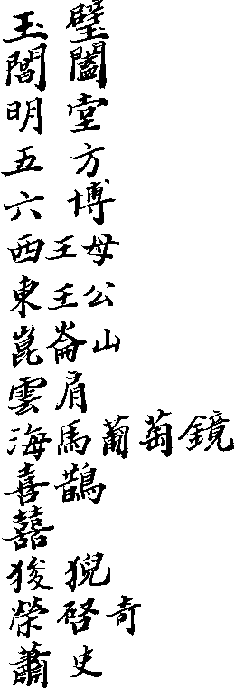 | as bb cc dd ee ff  99  hh  ii kk mm nn  00  AP qq rr ss tt uu

Chinese Characters
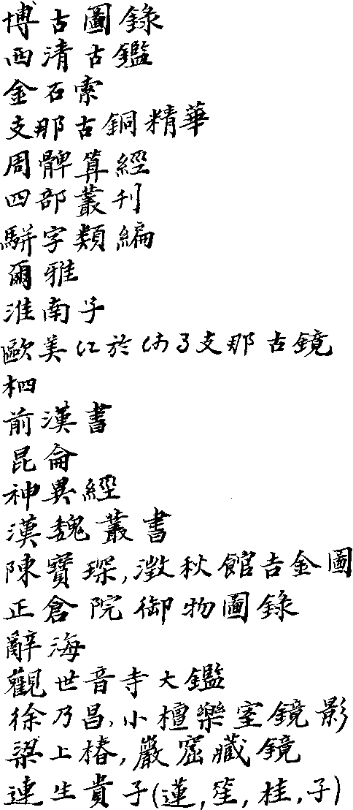

Fig. 1. Late Chou or Chin pi-type mirror.
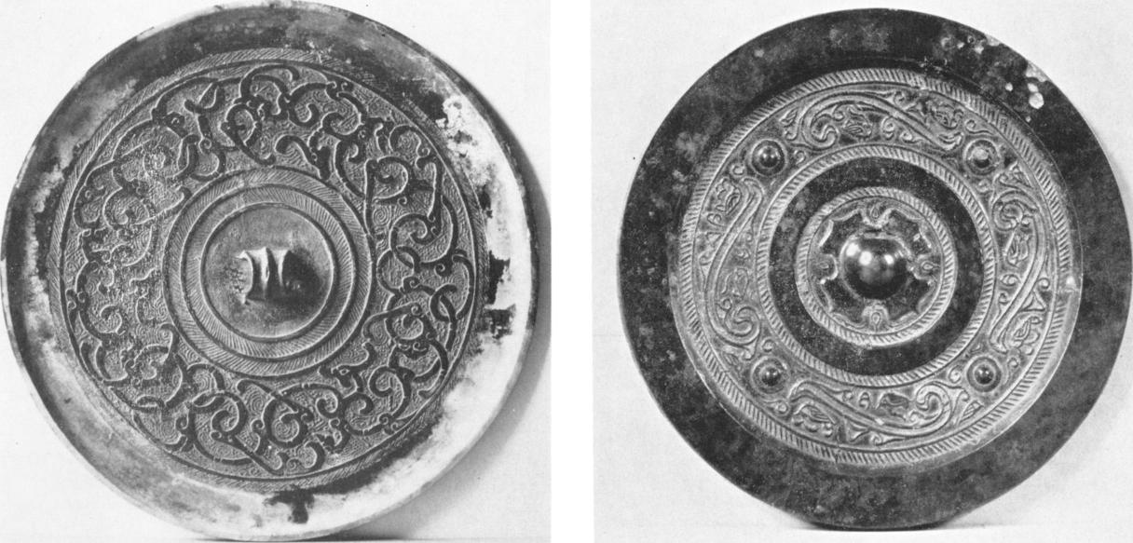
University Museum, Philadelphia.
Photo by Reuben Goldberg.
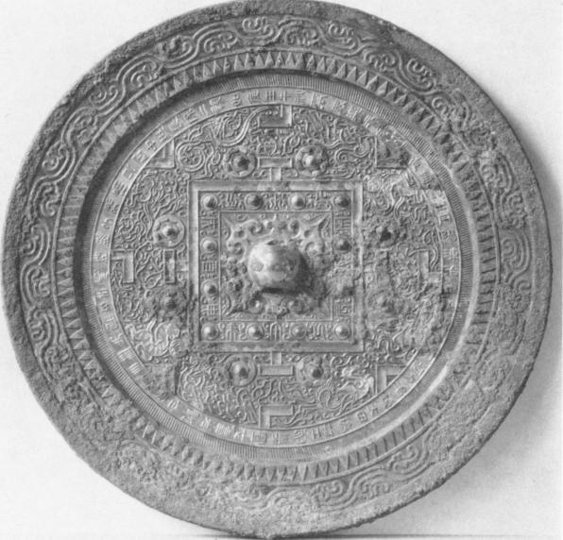
Fig. 3. Han cosmic mirror with "TLV" pattern.
Author's collection.
Photo by Reuben Goldberg.
Fig. 2. Han cosmic mirror.
University Museum, Philadelphia.
Photo by Reuben Goldberg.
Fig. 5. Late Han Hsi-wang-mu mirror.
^{,we}ibi^{n}ii;¹1;11
• /4⁻¹¹⁻„ ,¹""
' • '.iii ^{.6}'
¹.f '¹.„),
# • `..1 • al a•

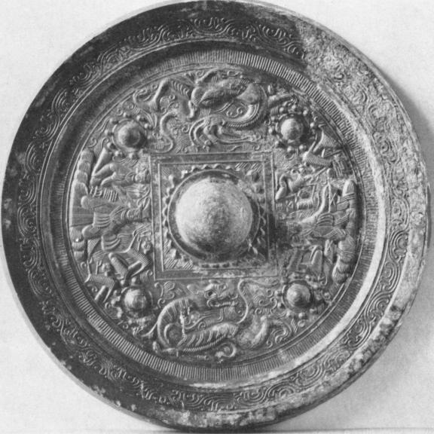
University Museum, Philadelphia.
Photo by Reuben Goldberg.

60
Fig. 6. Six Dynasties cosmic mirror with Hsi-wang-mu
and consort.
Author's collection.
Photo by Reuben Goldberg.
Fig. 7. Sui or Early Tang "Four Spirits" cosmic mirror.
Denver Art Museum.
Fig. 8. Sui or Early Tang "Five Lions" cosmic mirror.
Private collection.
'Aittstrewtw'm⁻'⁴". -
Fig. 9. Tang "Lion and Grape" mirror.
Richard C. Dull collection.
Photo by Reuben Goldberg.
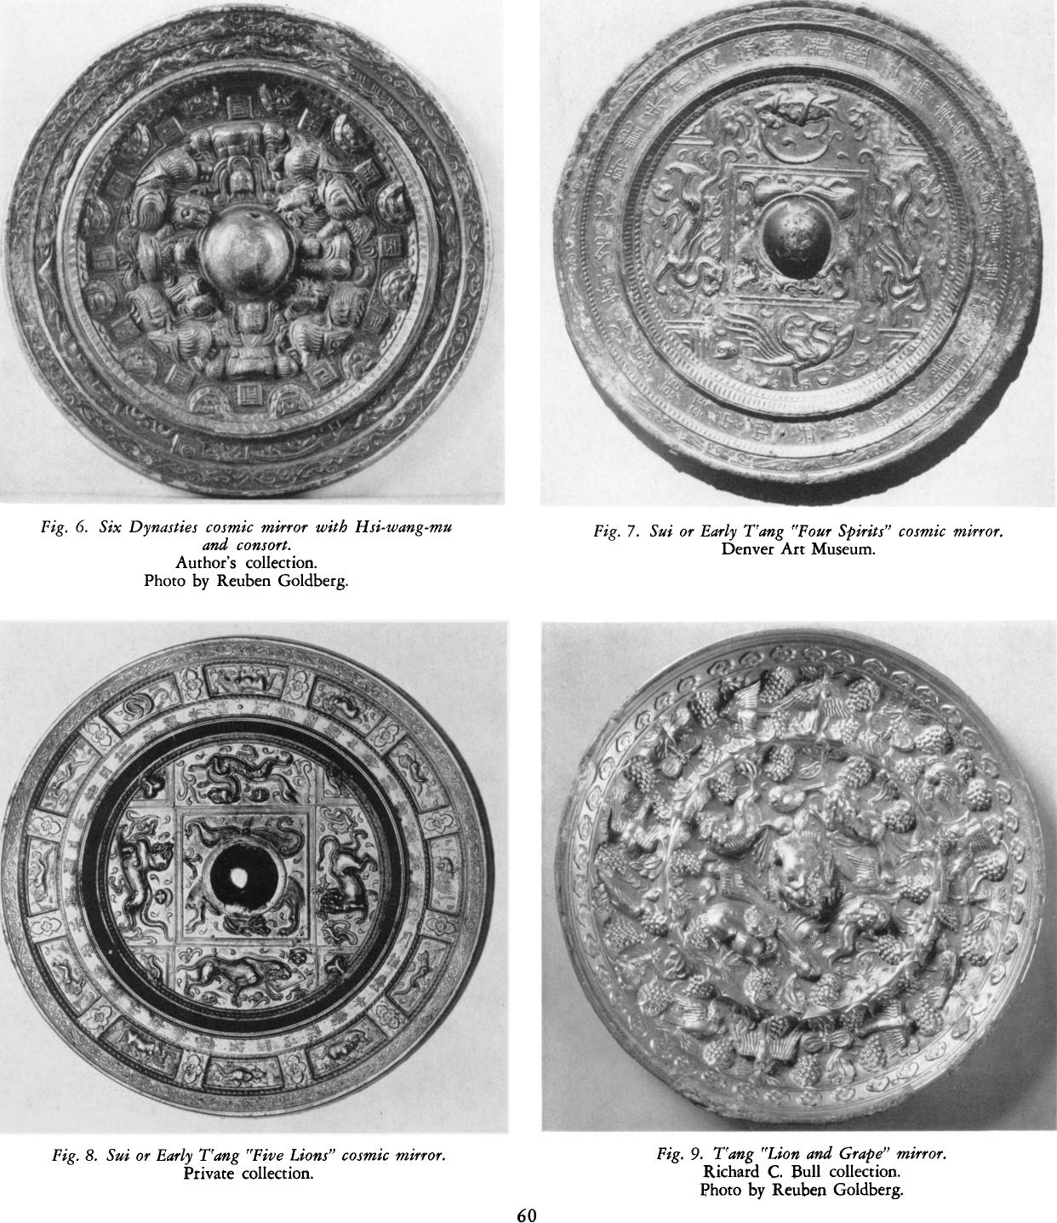
Fig. 10. Tang "Lion and Grape" mirror, with Fig. 11. Tang marriage mirror.
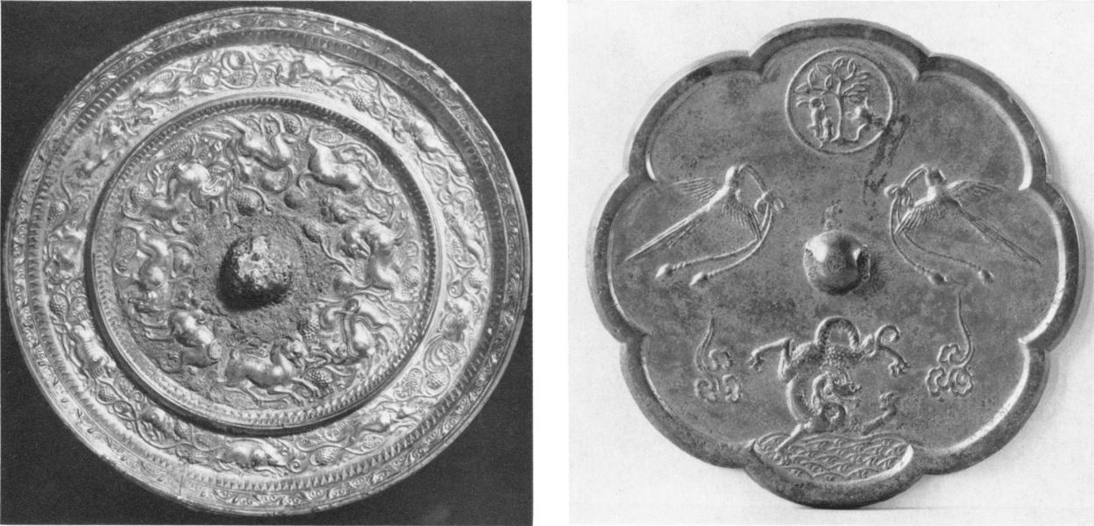
paired lions and zodiac. Author's collection.
Buffalo Museum of Science. Photo by Reuben Goldberg.

Fig. 12. Tang marriage mirror. Fig. 13. Tang cosmic-marriage mirror with
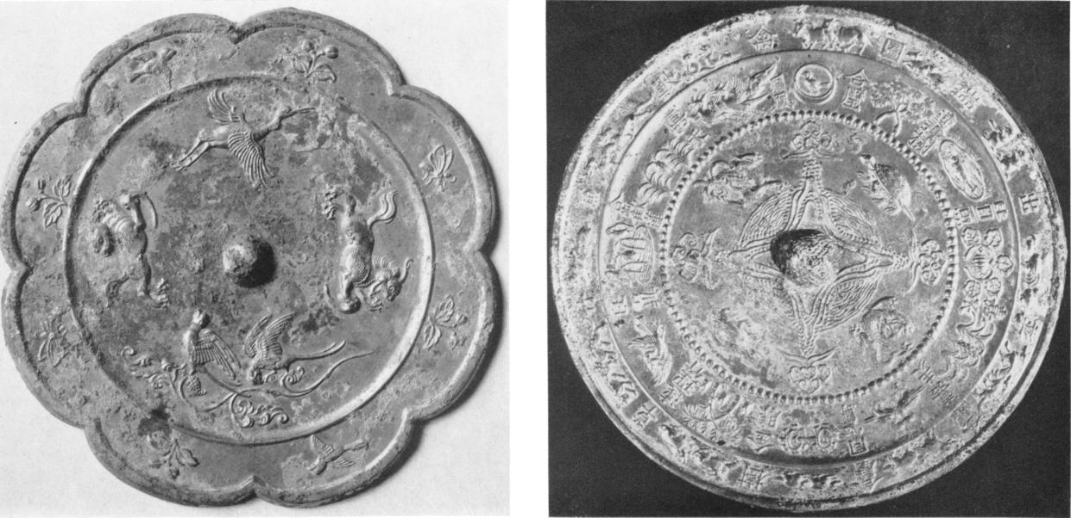
University Museum, Philadelphia. ancient auspicious symbols.
Photo by Reuben Goldberg. Seattle Art Museum.

Fig. 14. Late Tang cosmic mirror with zodiac, Fig. 15. Early Sung copy of Han "TLV" pattern, showing
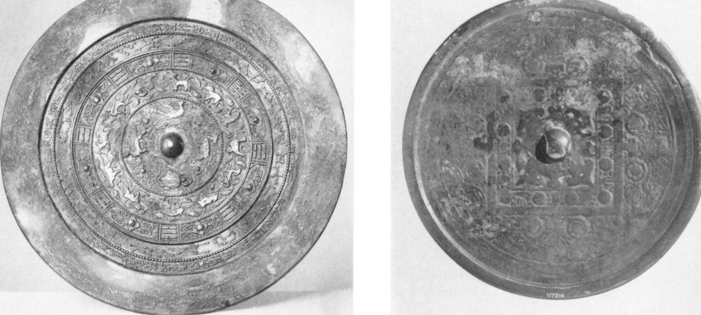
trigrams and constellations. degeneration of the design.
Chicago Museum of Natural History. Chicago Museum of Natural History.
Fig. 16. Sung copper-bronze mirror with  lotus and children.  Author's collection.  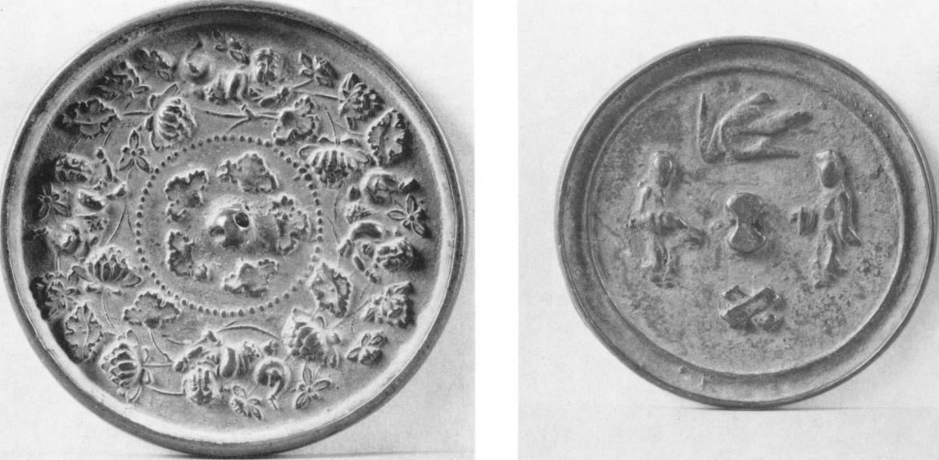 | Fig. 17. Ming marriage mirror.  University Museum, Philadelphia.  Photo by Reuben Goldberg.

